

Information Systems and Databases

**Report 2nd Project Assignment**

**Health care center database**

15/11/2017

1st Semester – 2017/2018

Professors: Mário Gaspar da Silva

Francisco Regateiro

Miguel Amaral

Group number 49:

81731 – Catarina Aleixo

81138 – João Ramiro

81567 – José Miragaia

1. **Create the database**

**create table** Patient

(patient_number **varchar**(255),

patient_name **varchar**(255),

birthday **date**,

address **varchar**(255),

**primary key**(patient_number));

**create table** Doctor

(patient_number **varchar**(255),

doctor_id **varchar**(255),

**primary key**(doctor_id),

**foreign key** (patient_number) **references** Patient(patient_number));

**create table** Device

(serialnum **varchar**(255),

manufacturer **varchar**(255),

model **varchar**(255),

**primary key**(serialnum, manufacturer));

**create table** Sensor

(serialnum **varchar**(255),

manufacturer **varchar**(255),

units **varchar**(255),

**primary key**(serialnum, manufacturer),

**foreign key**(serialnum, manufacturer) **references** Device(serialnum, manufacturer));

**create table** Reading

(serialnum **varchar**(255),

manufacturer **varchar**(255),

read_datetime **timestamp**,

value **float(10,2)**,

**primary key**(serialnum, manufacturer, read_datetime),

**foreign key**(serialnum, manufacturer) **references** Sensor(serialnum, manufacturer));

**create table** Period

(start_date **timestamp**,

end_date **timestamp**,

**primary key**(start_date, end_date));

**create table** Wears

(start_date **timestamp**,

end_date **timestamp**,

patient_number **varchar**(255),

serialnum **varchar**(255),

manufacturer **varchar**(255),

**primary key**(start_date, end_date, patient_number),

**foreign key**(start_date, end_date**) references** Period(start_date, end_date),

**foreign key**(patient_number) **references** Patient(patient_number),

**foreign key**(serialnum, manufacturer) **references** Device(serialnum, manufacturer));

**create table** Request

(request_number **int(10) UNSIGNED**,

patient_number **varchar**(255),

doctor_id **varchar**(255),

request_date **date**,

**primary key**(request_number),

**foreign key**(patient_number) **references** Patient(patient_number),

**foreign key**(doctor_id) **references** Doctor(doctor_id));

**create table** Study

(request_number **int(10) UNSIGNED**,

description **varchar**(255),

study_date **date**,

doctor_id **varchar**(255),

manufacturer **varchar**(255),

serialnum **varchar**(255),

**primary key**(request_number, description),

**foreign key**(request_number) **references** Request(request_number),

**foreign key**(doctor_id) **references** Doctor(doctor_id),

**foreign key**(serialnum, manufacturer) **references** Device(serialnum, manufacturer));

**create table** Series

(series_id **int(10) UNSIGNED**,

series_name **varchar(255),**

base_url **varchar(255),**

request_number **int(10) UNSIGNED**,

description **varchar**(255),

**primary key**(series_id),

**foreign key**(request_number, description) **references** Study(request_number, description));

**create table** Element

(series_id **int(10) UNSIGNED**,

elem_index **int(10) UNSIGNED**,

**primary key**(series_id, elem_index),

**foreign key**(series_id) **references** Series(series_id));

**create table** Region

(series_id **int(10) UNSIGNED**,

elem_index **int(10) UNSIGNED**,

x1 **float**(4,3),

y1 **float**(4,3),

x2 **float**(4,3),

y2 **float**(4,3),

**primary key**(series_id, elem_index, x1, y1, x2, y2),

**foreign key**(series_id, elem_index) Element(series_id, elem_index));

1. **Querys**

**1. Query to retrieve the name(s) of patient(s) with the highest number of readings of units of “LDL cholesterol in mg/dL” above 200 in the past 90 days**

**select** patient_name

**from** Patient **natural join** Reading **natural join** Sensor **natural join** Wears

**where** value > 200 **and** units **like** 'LDL cholesterol in mg/dL' **and**

**TIMESTAMPDIFF(**day, read_datetime, **CURRENT_TIMESTAMP())** <= 90

**group by** patient_name

**having count**(value) >= **all** (**select** **count**(value)

**from** Patient **natural join** Reading **natural join** Sensor **natural join** Wears

**where** value > 200 **and** units **like** 'LDL cholesterol in mg/dL' **and**

**TIMESTAMPDIFF(**day, read_datetime, **CURRENT_TIMESTAMP())** <= 90 **group by** patient_name);

**2. Query to retrieve the name(s) of patient(s) who have been subject of studies with all devices of manufacturer “Medtronic” in the past calendar year**

**select** patient_name

**from** Patient **as** p

**where not exists** (**select** serialnum

**from** Device **as** d

**where** manufacturer **like** 'Medtronic'

**and** serialnum **not in** (**select** serialnum

**from** Study **as** s, Request **as** r, Patient **as** p2

**where** s.request_number = r.request_number **and**

r.patient_number = p2.patient_number **and**

**TIMESTAMPDIFF(**year, s.study_date, **CURRENT_TIMESTAMP())** = 1 **and**

p.patient_name = p2.patient_name));

1. **Triggers**

**1. Trigger to ensure that a doctor who prescribes an exam may not perform that same exam**

In this version of *mysql*, it’s necessary to create two triggers: one for inserting data into Study table and another one for update it.

**delimiter $$**

**create trigger** prevent_insert **before** **insert on** Study

**for each row**

**begin**

**if exists**(**select \***

**from** Request

**where** request_number = new.request_number **and** doctor_id = new.doctor_id) **then**

**call** doctor_who_prescribes_an_exame_cannot_perform_the_same_exam();

**end if;**

**end$$**

**delimiter ;**

**delimiter $$**

**create trigger** prevent_update **before update on** Study

**for each row**

**begin**

**if exists**(**select \***

**from** Request

**where** request_number = new.request_number and doctor_id = new.doctor_id) **then**

**call** doctor_who_prescribes_an_exame_cannot_perform_the_same_exam();

**end if;**

**end$$**

**delimiter ;**

**2. Trigger to prevent someone from trying to associate a device to a patient in overlapping periods. Additionally, when this event occurs, a text message “Overlapping periods” will be thrown**

**delimiter $$**

**create trigger** prevent_device_association_insert **before insert on** Wears

**for each row**

**begin**

**if**(serialnum = new.serialnum **and** manufacturer = new.manufacturer **and**

((**TIMESTAMPDIFF**(second, new.start_date, start_date) >= 0 **and** **TIMESTAMPDIFF**(second, new.end_date, end_date) >= 0) **or**

(**TIMESTAMPDIFF**(second, start_date, new.start_date) >= 0 **and** TIMESTAMPDIFF(second, end_date, new.end_date) >= 0) **or**

(**TIMESTAMPDIFF**(second, start_date, new.start_date) >= 0 **and** **TIMESTAMPDIFF**(second, new.end_date, end_date) >= 0) **or**

(**TIMESTAMPDIFF**(second, new.start_date, start_date) >= 0 **and TIMESTAMPDIFF**(second, end_date, new.end_date) >= 0))) **then**

**signal sqlstate '45000' set message_text** = 'Overlapping Periods';

**end if;**

**end$$**

**delimiter ;**

**delimiter $$**

**create trigger** prevent_device_association_update **before insert on** Wears

**for each row**

**begin**

**if**(serialnum = new.serialnum **and** manufacturer = new.manufacturer **and**

((**TIMESTAMPDIFF**(second, new.start_date, start_date) >= 0 **and** **TIMESTAMPDIFF**(second, new.end_date, end_date) >= 0) **or**

(**TIMESTAMPDIFF**(second, start_date, new.start_date) >= 0 **and** TIMESTAMPDIFF(second, end_date, new.end_date) >= 0) **or**

(**TIMESTAMPDIFF**(second, start_date, new.start_date) >= 0 **and** **TIMESTAMPDIFF**(second, new.end_date, end_date) >= 0) **or**

(**TIMESTAMPDIFF**(second, new.start_date, start_date) >= 0 **and TIMESTAMPDIFF**(second, end_date, new.end_date) >= 0))) **then**

**signal sqlstate '45000' set message_text** = 'Overlapping Periods';

**end if;**

**end$$**

**delimiter ;**

1. **Function**

**delimiter $$**

**create function** region_overlaps_element(series_id_A int(10), elem_index_A int(10), x1_B float(4,3), y1_B float(4,3), x2_B float(4,3), y2_B float(4,3))

**returns int**

**begin**

**declare** overlaps **int**;

**select count**(r.elem_index) **into** overlaps

**from** region **as** r

**where** r.series_id = series_id_A **and** r.elem_index = elem_index_A **and**

(((x1_B **between** r.x1 **and** r.x2) **or** (x2_B **between** r.x1 **and** r.x2)) **and**

((y1_B **between** r.y1 **and** r.y2) **or** (y2_B **between** r.y1 **and** r.y2)) **or**

((x1_B > r.x1) **and** (x2_B < r.x2) **and** (y1_B > r.y1) **and** (y2_B < r.y2)) **or**

((x1_B < r.x1) **and** (x2_B > r.x2) **and** (y1_B < r.y1) **and** (y2_B > r.y2)));

**if** overlaps > 0 **then**

**set** overlaps = 1;

**end if;**

**return** overlaps;

**end$$**

**delimiter ;**

This function *region_overlaps_element()* checks if a given Region B (x1_B, y1_B, x2_B, y2_B) overlaps with any region of Element A (series_id_A, elem_index_A). If overlaps return 1 (means TRUE). Otherwise returns 0 (means FALSE).

1. **Populate tables**

**insert into** Patient **values** ('P-1', 'John Smith', '1990-07-01', 'London');

**insert into** Patient **values** ('P-2', 'Roger Smith', '1987-05-05', 'Liverpool');

**insert into** Patient **values** ('P-3', 'James Bond', '1975-08-30', 'Bristol');

**insert into** Patient **values** ('P-4', 'Kelly Fernandez', '1985-10-06', 'London');

**insert into** Patient **values** ('P-5', 'Liz Wang', '1987-12-25', 'Birmingham');

**insert into** Patient **values** ('P-6', 'Richard Gun', '1965-11-15', 'Manchester');

**insert into** Patient **values** ('P-7', 'Gisele Joly', '1950-02-07', 'Manchester');

**insert into** Patient **values** ('P-8', 'Isaac Newton', '1966-04-09', 'Sheffield');

**insert into** Patient **values** ('P-9', 'Lilian Holmes', '1955-06-20', 'Liverpool');

**insert into** Patient **values** ('P-10', 'Wellington Ramirez', '1959-09-14', 'London');

**insert into** Doctor **values** ('P-1', 'D-101');

**insert into** Doctor **values** ('P-2', 'D-102');

**insert into** Doctor **values** ('P-3', 'D-103');

**insert into** Doctor **values** ('P-4', 'D-104');

**insert into** Doctor **values** ('P-5', 'D-105');

**insert into** Doctor **values** ('P-6', 'D-106');

**insert into** Doctor **values** ('P-7', 'D-107');

**insert into** Doctor **values** ('P-8', 'D-108');

**insert into** Doctor **values** ('P-9', 'D-109');

**insert into** Doctor **values** ('P-10', 'D-110');

**insert into** Device **values** ('S1', 'Siemens', 's6373');

**insert into** Device **values** ('B1', 'Bosch', 'b7566');

**insert into** Device **values** ('A1', 'Airsense', 'a9800');

**insert into** Device **values** ('A2', 'Airsense', 'a7658');

**insert into** Device **values** ('A3', 'Airsense', 'a3333');

**insert into** Device **values** ('A4', 'Airsense', 'a3333');

**insert into** Device **values** ('A5', 'Airsense', 'a9800');

**insert into** Device **values** ('S2', 'Siemens', 's3421');

**insert into** Device **values** ('B2', 'Bosch', 'b8765');

**insert into** Device **values** ('T1', 'Thermotec', 't2990');

**insert into** Device **values** ('T2', 'Thermotec', 't2990');

**insert into** Device **values** ('H1', 'Honeywell', 'h6776');

**insert into** Device **values** ('H2', 'Honeywell', 'h4444');

**insert into** Device **values** ('E1', 'Envitec', 'e5876');

**insert into** Device **values** ('E2', 'Envitec', 'e5876');

**insert into** Device **values** ('M1', 'Medtronic', 'm7891');

**insert into** Device **values** ('M2', 'Medtronic', 'm4536');

**insert into** Device **values** ('M3', 'Medtronic', 'm6543');

**insert into** Device **values** ('M4', 'Medtronic', 'm9023');

**insert into** Device **values** ('M5', 'Medtronic', 'm7123');

**insert into** Device **values** ('S3', 'Siemens', 's4040');

**insert into** Device **values** ('S4', 'Siemens', 's3131');

**insert into** Device **values** ('S5', 'Siemens', 's1111');

**insert into** Device **values** ('B3', 'Bosch', 'b4589');

**insert into** Device **values** ('B4', 'Bosch', 'b3232');

**insert into** Device **values** ('B5', 'Bosch', 'b4455');

**insert into** Device **values** ('I1', 'Iberdata', 'i3030');

**insert into** Device **values** ('I2', 'Iberdata', 'i9009');

**insert into** Device **values** ('I3', 'Iberdata', 'i7050');

**insert into** Device **values** ('I4', 'Iberdata', 'i3553');

**insert into** Device **values** ('I5', 'Iberdata', 'i7005');

**insert into** Device **values** ('I6', 'Iberdata', 'i6531');

**insert into** Sensor **values** ('S1', 'Siemens', 'LDL cholesterol in mg/dL');

**insert into** Sensor **values** ('B1', 'Bosch', 'Creatinine in mg/L');

**insert into** Sensor **values** ('A1', 'Airsense', 'HDL cholesterol in mg/dL');

**insert into** Sensor **values** ('A2', 'Airsense', 'Hemoglobin in g/dL');

**insert into** Sensor **values** ('A3', 'Airsense', 'Creatinine in mg/L');

**insert into** Sensor **values** ('A4', 'Airsense', 'Creatinine in mg/L');

**insert into** Sensor **values** ('A5', 'Airsense', 'Hemoglobin in g/dL');

**insert into** Sensor **values** ('S2', 'Siemens', 'HDL cholesterol in mg/dL');

**insert into** Sensor **values** ('B2', 'Bosch', 'LDL cholesterol in mg/dL');

**insert into** Sensor **values** ('T1', 'Thermotec', 'Temperature in ºC');

**insert into** Sensor **values** ('T2', 'Thermotec', 'Temperature in ºC');

**insert into** Sensor **values** ('H1', 'Honeywell', 'Glucose level in mmol/L');

**insert into** Sensor **values** ('H2', 'Honeywell', 'Glucose level in mmol/L');

**insert into** Sensor **values** ('E1', 'Envitec', 'Hemoglobin in g/dL');

**insert into** Sensor **values** ('E2', 'Envitec', 'Creatinine in mg/L');

**insert into** Reading **values** ('S1', 'Siemens', '2017-10-30 18:20:00', 217);

**insert into** Reading **values** ('S1', 'Siemens', '2017-10-30 18:21:00', 225);

**insert into** Reading **values** ('S1', 'Siemens', '2017-10-15 13:12:11', 220);

**insert into** Reading **values** ('S1', 'Siemens', '2017-10-17 20:08:21', 201);

**insert into** Reading **values** ('B1', 'Bosch', '2017-10-15 10:17:55', 10.1);

**insert into** Reading **values** ('A1', 'Airsense', '2017-07-31 15:25:45', 77);

**insert into** Reading **values** ('A1', 'Airsense', '2017-08-7 08:54:07', 100);

**insert into** Reading **values** ('A2', 'Airsense', '2017-10-31 09:57:35', 12.8);

**insert into** Reading **values** ('A2', 'Airsense', '2017-03-17 11:47:59', 15.7);

**insert into** Reading **values** ('A3', 'Airsense', '2016-12-25 20:20:20', 8.2);

**insert into** Reading **values** ('A4', 'Airsense', '2017-01-20 23:17:05', 11.8);

**insert into** Reading **values** ('A5', 'Airsense', '2017-03-29 21:40:47', 17.2);

**insert into** Reading **values** ('S2', 'Siemens', '2017-01-29 19:20:27', 117);

**insert into** Reading **values** ('B2', 'Bosch', '2017-10-14 10:39:06', 224);

**insert into** Reading **values** ('T1', 'Thermotec', '2017-10-28 07:44:21', 35);

**insert into** Reading **values** ('T2', 'Thermotec', '2016-04-06 09:45:17', 36.5);

**insert into** Reading **values** ('T2', 'Thermotec', '2016-07-16 11:12:12', 34.7);

**insert into** Reading **values** ('H1', 'Honeywell', '2017-10-31 12:55:59', 5.9);

**insert into** Reading **values** ('H2', 'Honeywell', '2016-04-17 14:32:58', 7.5);

**insert into** Reading **values** ('E1', 'Envitec', '2016-01-30 16:27:44', 17.9);

**insert into** Reading **values** ('E2', 'Envitec', '2017-05-29 19:42:28', 12.2);

**insert into** Period **values** ('2017-04-01 10:00:01', '2017-10-31 17:18:19');

**insert into** Period **values** ('2017-01-17 08:11:17', '2017-10-25 19:00:91');

**insert into** Period **values** ('2016-01-02 10:08:00', '2030-12-31 00:00:00');

**insert into** Period **values** ('2017-03-04 12:34:55', '2030-12-31 00:00:00');

**insert into** Period **values** ('2015-05-08 22:30:05', '2030-12-31 00:00:00');

**insert into** Period **values** ('2016-02-26 13:08:45', '2030-12-31 00:00:00');

**insert into** Period **values** ('2016-07-31 15:03:41', '2017-09-17 13:00:07');

**insert** **into** Period **values** ('2016-08-26 21:00:23', '2017-02-23 17:55:42');

**insert into** Period **values** ('2017-04-06 12:07:44', '2030-12-31 00:00:00');

**insert into** Period **values** ('2016-01-12 00:00:00', '2017-11-02 07:15:18');

**insert into** Period **values** ('2017-05-10 11:12:15', '2030-12-31 00:00:00');

**insert into** Period **values** ('2016-04-2 08:11:17', '2016-12-15 00:00:00');

**insert into** Period **values** ('2016-03-20 20:17:25', '2017-01-01 10:00:10');

**insert into** Period **values** ('2016-01-07 12:00:15', '2016-04-28 17:17:17');

**insert into** Period **values** ('2016-01-02 09:30:27', '2016-01-07 18:20:24');

**insert into** Wears **values** ('2017-04-01 10:00:01', '2017-10-31 17:18:19', 'P-1', 'S1', 'Siemens');

**insert into** Wears **values** ('2017-01-17 08:11:17', '2017-10-25 19:00:21', 'P-2', 'B1', 'Bosch');

**insert into** Wears **values** ('2016-01-02 10:08:00', '2030-12-31 00:00:00', 'P-3', 'A1', 'AirSense');

**insert into** Wears **values** ('2017-03-04 12:34:55', '2030-12-31 00:00:00', 'P-4', 'A2', 'AirSense');

**insert into** Wears **values** ('2015-05-08 22:30:05', '2030-12-31 00:00:00', 'P-5', 'A3', 'AirSense');

**insert into** Wears **values** ('2016-02-26 13:08:45', '2030-12-31 00:00:00', 'P-6', 'A4', 'AirSense');

**insert into** Wears **values** ('2016-07-31 15:03:41', '2017-09-17 13:00:07', 'P-7', 'A5', 'AirSense');

**insert into** Wears **values** ('2016-08-26 21:00:23', '2017-02-23 17:55:42', 'P-8', 'S2', 'Siemens');

**insert into** Wears **values** ('2017-04-06 12:07:44', '2030-12-31 00:00:00', 'P-9', 'B2', 'Bosch');

**insert into** Wears **values** ('2016-01-12 00:00:00', '2017-11-02 07:15:18', 'P-10', 'T1', 'Thermotec');

**insert into** Wears **values** ('2017-05-10 11:12:15', '2030-12-31 00:00:00', 'P-8', 'H1', 'Honeywell');

**insert into** Wears **values** ('2016-04-02 08:11:10', '2016-12-15 00:01:10', 'P-2', 'T2', 'Thermotec');

**insert into** Wears **values** ('2016-03-20 20:17:25', '2017-01-01 10:00:10', 'P-1', 'H2', 'Honeywell');

**insert into** Wears **values** ('2016-01-07 12:00:15', '2016-04-28 17:17:17', 'P-7', 'E1', 'Envitec');

**insert into** Wears **values** ('2016-01-02 09:30:27', '2016-01-07 18:20:24', 'P-10', 'E2', 'Envitec');

**insert into** Request **values** (1, 'P-1', 'D-101', '2016-02-07');

**insert into** Request **values** (2, 'P-2', 'D-102', '2017-07-17');

**insert into** Request **values** (3, 'P-3', 'D-103', '2016-05-15');

**insert into** Request **values** (4, 'P-4', 'D-104', '2017-08-31');

**insert into** Request **va**l**ues** (5, 'P-5', 'D-105', '2016-10-16');

**insert into** Request **values** (6, 'P-6', 'D-106', '2016-09-21');

**insert into** Request **values** (7, 'P-7', 'D-107', '2017-04-19');

**insert** **into** Request **values** (8, 'P-8', 'D-108', '2017-01-21');

**insert into** Request **values** (9, 'P-9', 'D-109', '2016-12-16');

**insert into** Request **values** (10, 'P-10' 'D-110', '2017-06-25');

**insert into** Request **values** (11, 'P-5', 'D-105', '2017-05-09');

**insert into** Request **values** (12, 'P-7', 'D-107', '2017-10-24');

**insert into** Request **values** (13, 'P-8', 'D-108', '2016-07-05');

**insert into** Request **values** (14, 'P-2', 'D-102', '2016-04-02');

**insert into** Request **values** (15, 'P-1', 'D-101', '2016-10-09');

**insert into** Request **values** (16, 'P-3', 'D-103', '2017-09-06');

**insert into** Request **values** (17, 'P-4', 'D-104', '2017-03-11');

**insert into** Request **values** (18, 'P-3', 'D-103', '2016-02-10');

**insert** **into** Request **values** (19, 'P-3', 'D-103', '2016-04-03');

**insert into** Request **values** (20, 'P-3', 'D-103', '2016-07-20');

**insert into** Request **values** (21, 'P-3', 'D-103', '2016-09-07');

**insert into** Study **values** (1, 'X-ray both feet', '2016-03-05', 'D-102', 'Medtronic', 'M1');

**insert into** Study **values** (2, 'Ecography both feet', '2017-08-30', 'D-101', 'Medtronic', 'M2');

**insert into** Study **values** (3, 'Endoscopy esophagus', '2016-06-02', 'D-105', 'Medtronic', 'M3');

**insert into** Study **values** (4, 'Endoscopy stomach', '2017-10-07', 'D-103', 'Medtronic', 'M4');

**insert into** Study **values** (5, 'Echocardiography', '2016-10-31', 'D-104', 'Medtronic', 'M5');

**insert into** Study **values** (6, 'Mammography', '2016-03-05', 'D-107', 'Iberdata', 'I6');

**insert into** Study **values** (7, 'Colonoscopy', '2017-05-12', 'D-110', 'Siemens', 'S3');

**insert into** Study **values** (8, 'Magnetic Resonance both shoulders', '2017-02-25', 'D-101', 'Siemens', 'S4');

**insert into** Study **values** (9, 'Magnetic Resonance both knees', '2017-01-08', 'D-108', 'Siemens', 'S5');

**insert into** Study **values** (10, 'Electrocardiogram', '2017-07-27', 'D-109', 'Bosch', 'B3');

**insert into** Study **values** (11, 'Electrocardiogram', '2017-10-08', 'D-106', 'Bosch', 'B4');

**insert into** Study **values** (12, 'Prostate Specific Antigen (PSA test)', '2017-10-31', 'D-102', 'Bosch', 'B5');

**insert into** Study **values** (13, 'Mammography', '2017-07-27', 'D-107', 'Iberdata', 'I1');

**insert into** Study **values** (14, 'Colonoscopy', '2017-05-09', 'D-105', 'Iberdata', 'I2');

**insert into** Study **values** (15, 'Echocardiography', '2017-10-29', 'D-108', 'Iberdata', 'I3');

**insert into** Study **values** (16, 'X-ray chest', '2017-10-01', 'D-102', 'Iberdata', 'I4');

**insert into** Study **values** (17, 'X-ray both elbows', '2017-05-27', 'D-101', 'Iberdata', 'I5');

**insert into** Study **values** (18, 'X-ray right foot', '2016-03-25', 'D-104', 'Medtronic', 'M1');

**insert into** Study **values** (19, 'Ecography left foot', '2016-08-31', 'D-109', 'Medtronic', 'M2');

**insert into** Study **values** (20, 'Endoscopy stomach', '2016-10-10', 'D-110', 'Medtronic', 'M4');

**insert into** Study **values** (21, 'Echocardiography', '2016-10-17', 'D-105', 'Medtronic', 'M5');

**insert into** Series **values** (1, 'X-ray right foot', 'http://www.healthcarecentre/11/', 1, 'X-ray both feet');

**insert into** Series **values** (2, 'X-ray left foot', 'http://www.healthcarecentre/21/', 1, 'X-ray both feet');

**insert into** Series **values** (3, 'Ecography right foot', 'http://www.healthcarecentre/32/', 2, 'Ecography both feet');

**insert into** Series **values** (4, 'Ecography left foot', 'http://www.healthcarecentre/42/', 2, 'Ecography both feet');

**insert into** Series **values** (5, 'Endoscopy esophagus', 'http://www.healthcarecentre/53/', 3, 'Endoscopy esophagus');

**insert into** Series **values** (6, 'Endoscopy stomach', 'http://www.healthcarecentre/64/', 4, 'Endoscopy stomach');

**insert into** Series **values** (7, 'Echocardiography', 'http://www.healthcarecentre/75/', 5, 'Echocardiography');

**insert into** Series **values** (8, 'Mammography', 'http://www.healthcarecentre/86/', 6, 'Mammography');

**insert into** Series **values** (9, 'Colonoscopy', 'http://www.healthcarecentre/97/', 7, 'Colonoscopy');

**insert into** Series **values** (10, 'Magnetic Resonance right shoulder', 'http://www.healthcarecentre/108/', 8, 'Magnetic Resonance both shoulders');

**insert into** Series **values** (11, 'Magnetic Resonance left shoulder', 'http://www.healthcarecentre/118/', 8, 'Magnetic Resonance both shoulders');

**insert into** Series **values** (12, 'Magnetic Resonance right knee', 'http://www.healthcarecentre/129/', 9, 'Magnetic Resonance both shoulders');

**insert into** Series **values** (13, 'Magnetic Resonance left knee', 'http://www.healthcarecentre/139/', 9, 'Magnetic Resonance both shoulders');

**insert into** Series **values** (14, 'Electrocardiogram', 'http://www.healthcarecentre/1410/', 10, 'Electrocardiogram');

**insert into** Series **values** (15, 'Electrocardiogram', 'http://www.healthcarecentre/1511/', 11, 'Electrocardiogram');

**insert into** Series **values** (16, 'Prostate Specific Antigen (PSA test)', 'http://www.healthcarecentre/1612/', 12, 'Prostate Specific Antigen (PSA test)');

**insert into** Series **values** (17, 'Mammography', 'http://www.healthcarecentre/1713/', 13, 'Mammography');

**insert into** Series **values** (18, 'Colonoscopy', 'http://www.healthcarecentre/1814/', 14, 'Colonoscopy');

**insert into** Series **values** (19, 'Echocardiography', 'http://www.healthcarecentre/1915/', 15, 'Echocardiography');

**insert into** Series **values** (20, 'X-ray chest', 'http://www.healthcarecentre/2016/', 16, 'X-ray chest');

**insert into** Series **values** (21, 'X-ray right elbow', 'http://www.healthcarecentre/2117/', 17, 'X-ray both elbows');

**insert into** Series **values** (22, 'X-ray left elbow', 'http://www.healthcarecentre/2217/', 17, 'X-ray both elbows');

**insert into** Series **values** (23, 'X-ray right foot', 'http://www.healthcarecentre/2318/', 18, 'X-ray right foot');

**insert into** Series **values** (24, 'Ecography left foot', 'http://www.healthcarecentre/2419/', 19, 'Ecography left foot');

**insert into** Series **values** (25, 'Endoscopy stomach', 'http://www.healthcarecentre/2520/', 20, 'Endoscopy stomach');

**insert into** Series **values** (26, 'Echocardiography', 'http://www.healthcarecentre/2621/', 21, 'Echocardiography');

**insert into** Element **values** (1, 1);

**insert into** Element **values** (1, 2);

**insert into** Element **values** (1, 3);

**insert into** Element **values** (2, 1);

**insert into** Element **values** (2, 2);

**insert into** Element **values** (3, 1);

**insert into** Element **values** (3, 2);

**insert into** Element **values** (3, 3);

**insert into** Element **values** (3, 4);

**insert into** Element **values** (4, 1);

**insert into** Element **values** (4, 2);

**insert into** Element **values** (5, 1);

**insert into** Element **values** (5, 2);

**insert into** Element **values** (6, 1);

**insert into** Element **values** (6, 2);

**insert into** Element **values** (7, 1);

**insert into** Element **values** (7, 2);

**insert into** Element **values** (8, 1);

**insert into** Element **values** (8, 2);

**insert into** Element **values** (8, 3);

**insert into** Element **values** (8, 4);

**insert into** Element **values** (9, 1);

**insert into** Element **values** (9, 2);

**insert into** Element **values** (10, 1);

**insert into** Element **values** (10, 2);

**insert into** Element **values** (11, 1);

**insert into** Element **values** (11, 2);

**insert into** Element **values** (12, 1);

**insert into** Element **values** (12, 2);

**insert into** Element **values** (13, 1);

**insert into** Element **values** (13, 2);

**insert into** Element **values** (14, 1);

**insert into** Element **values** (14, 2);

**insert into** Element **values** (15, 1);

**insert into** Element **values** (15, 2);

**insert into** Element **values** (16, 1);

**insert into** Element **values** (16, 2);

**insert into** Element **values** (17, 1);

**insert into** Element **values** (17, 2);

**insert into** Element **values** (18, 1);

**insert into** Element **values** (18, 2);

**insert into** Element **values** (19, 1);

**insert into** Element **values** (19, 2);

**insert into** Element **values** (20, 1);

**insert into** Element **values** (20, 2);

**insert into** Element **values** (21, 1);

**insert into** Element **values** (21, 2);

**insert** **into** Element **values** (22, 1);

**insert into** Element **values** (22, 2);

**insert into** Element **values** (22, 3);

i**nsert into** Element **values** (22, 4);

**insert into** Region **values** (1, 1, 0.107, 0.638, 0.180, 0.762);

**insert into** Region **values** (1, 2, 0.230, 0.567, 0.443, 0.899);

**insert into** Region **values** (1, 3, 0.432, 0.565, 0.118, 0.779);

**insert into** Region **values** (2, 1, 0.508, 0.234, 0.734, 0.923);

**insert into** Region **values** (2, 1, 0.100, 0.100, 0.230, 0.230);

**insert into** Region **values** (2, 2, 0.214, 0.657, 0.978, 0.999);

**insert into** Region **values** (3, 1, 0.115, 0.376, 0.647, 0.762);

**insert into** Region **values** (3, 2, 0.534, 0.980, 0.234, 0.762);

**insert into** Region **values** (3, 3, 0.675, 0.192, 0.567, 0.762);

**insert into** Region **values** (3, 4, 0.453, 0.876, 0.290, 0.834);

**insert into** Region **values** (4, 1, 0.489, 0.789, 0.117, 0.878);

**insert into** Region **values** (4, 2, 0.222, 0.333, 0.444, 0.555);

**insert into** Region **values** (5, 1, 0.654, 0.218, 0.905, 0.675);

**insert into** Region **values** (5, 2, 0.232, 0.798, 0.190, 0.458);

**insert into** Region **values** (6, 1, 0.616, 0.717, 0.818, 0.919);

**insert into** Region **values** (6, 2, 0.111, 0.999, 0.222, 0.777);

**insert into** Region **values** (7, 1, 0.668, 0.669, 0.888, 0.889);

**insert into** Region **values** (7, 2, 0.558, 0.475, 0.222, 0.332);

**insert into** Region **values** (8, 1, 0.142, 0.173, 0.194, 0.289);

**insert into** Region **values** (8, 2, 0.765, 0.975, 0.333, 0.777);

**insert into** Region **values** (8, 3, 0.211, 0.991, 0.224, 0.664);

**insert into** Region **values** (8, 4, 0.168, 0.845, 0.333, 0.456);

**insert into** Region **values** (9, 1, 0.121, 0.343, 0.565, 0.787);

**insert into** Region **values** (9, 2, 0.099, 0.677, 0.345, 0.899);

**insert into** Region **values** (10, 1, 0.321, 0.654, 0.765, 0.987);

**insert into** Region **values** (10, 2, 0.545, 0.878, 0.688, 0.727);

**insert into** Region **values** (11, 1, 0.646, 0.789, 0.889, 0.989);

**insert into** Region **values** (11, 2, 0.109, 0.234, 0.565, 0.898);

**insert into** Region **values** (12, 1, 0.212, 0.245, 0.656, 0.787);

**insert into** Region **values** (12, 2, 0.893, 0.909, 0.345, 0.897);

**insert into** Region **values** (13, 1, 0.666, 0.999, 0.222, 0.666);

**insert into** Region **values** (13, 2, 0.878, 0.989, 0.356, 0.676);

**insert into** Region **values** (14, 1, 0.111, 0.225, 0.348, 0.987);

**insert into** Region **values** (14, 2, 0.590, 0.334, 0.212, 0.455);

**insert into** Region **values** (15, 1, 0.690, 0.990, 0.213, 0.676);

**insert into** Region **values** (15, 2, 0.276, 0.387, 0.432, 0.878);

**insert into** Region **values** (16, 1, 0.175, 0.345, 0.478, 0.889);

**insert into** Region **values** (16, 2, 0.289, 0.367, 0.878, 0.995);

**insert into** Region **values** (17, 1, 0.567, 0.890, 0.345, 0.789);

**insert into** Region **values** (17, 2, 0.465, 0.443, 0.556, 0.954);

**insert into** Region **values** (18, 1, 0.586, 0.669, 0.665, 0.753);

**insert into** Region **values** (18, 2, 0.123, 0.456, 0.789, 0.890);

**insert into** Region **values** (19, 1, 0.643, 0.717, 0.542, 0.999);

**insert into** Region **values** (19, 2, 0.545, 0.878, 0.688, 0.727);

**insert into** Region **values** (20, 1, 0.534, 0.796, 0.968, 0.998);

**insert into** Region **values** (20, 2, 0.321, 0.543, 0.765, 0.987);

**insert into** Region **values** (21, 1, 0.199, 0.299, 0.399, 0.599);

**insert into** Region **values** (21, 2, 0.209, 0.309, 0.409, 0.509);

**insert into** Region **values** (22, 1, 0.534, 0.756, 0.867, 0.957);

**insert into** Region **values** (22, 2, 0.476, 0.874, 0.565, 0.878);

**insert into** Region **values** (22, 3, 0.223, 0.345, 0.678, 0.967);

**insert into** Region **values** (22, 4, 0.234, 0.678, 0.456, 0.789);

1. **Expected Results**

* Figure 1 shows the result of the first query, which are the patients with the highest number of readings of ‘LDL cholesterol in mg/dL’ above 200 in the past 90 days :
* 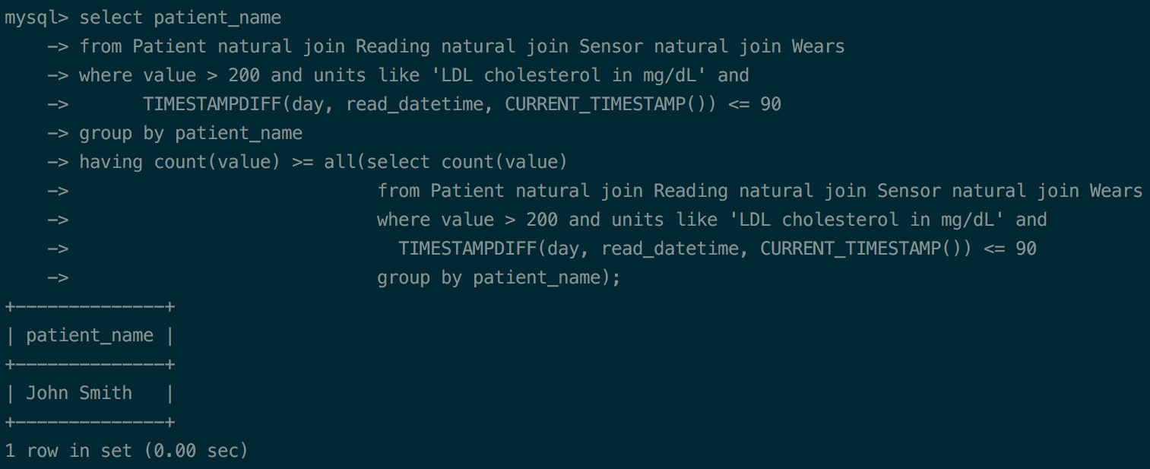Figure 2 shows the result of the second query, which are the patients who have been subject of studies with all devices of manufacturer ‘Medtronic’:

Figure 1 – Result of the first query

* 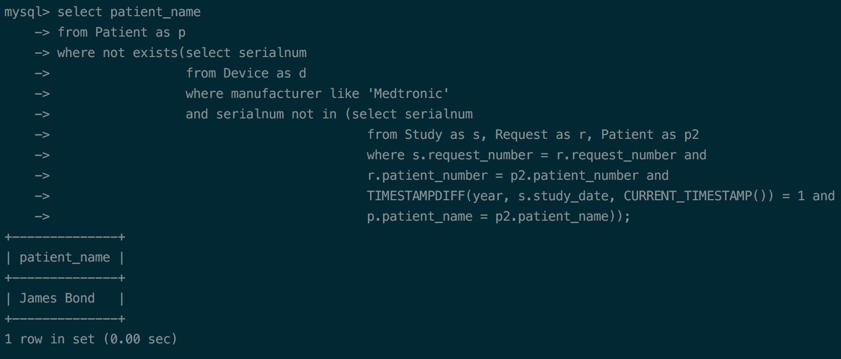Figures 3.1 and 3.2 show examples of the implementation of trigger 1, one for inserting a new record (prevent_insert) and another one for updating an existing row (prevent_update), in the table Study, respectively:

Figure 2 - Result of the second query

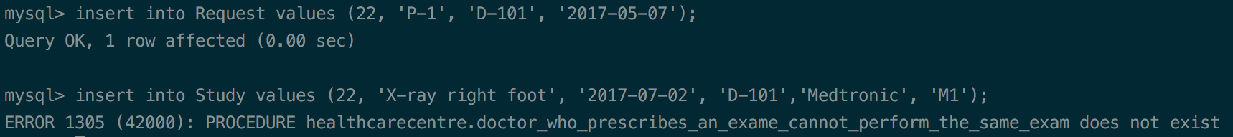

Figure 3.2 - Trigger 1 (prevent_update) example for updating an existing row, trying to change the doctor of a study to the same doctor that made the request

Figure 3.1 - Trigger 1 (prevent_insert) example for trying to insert a record in Study table that has the same doctor that requested the exam

* Figures 4.1 and 4.2 show examples of the implementation of trigger 2, one for inserting a new record (prevent_device_association_insert) and another one for updating an existing row (prevent_device_association_update) in the table Wears, respectively:

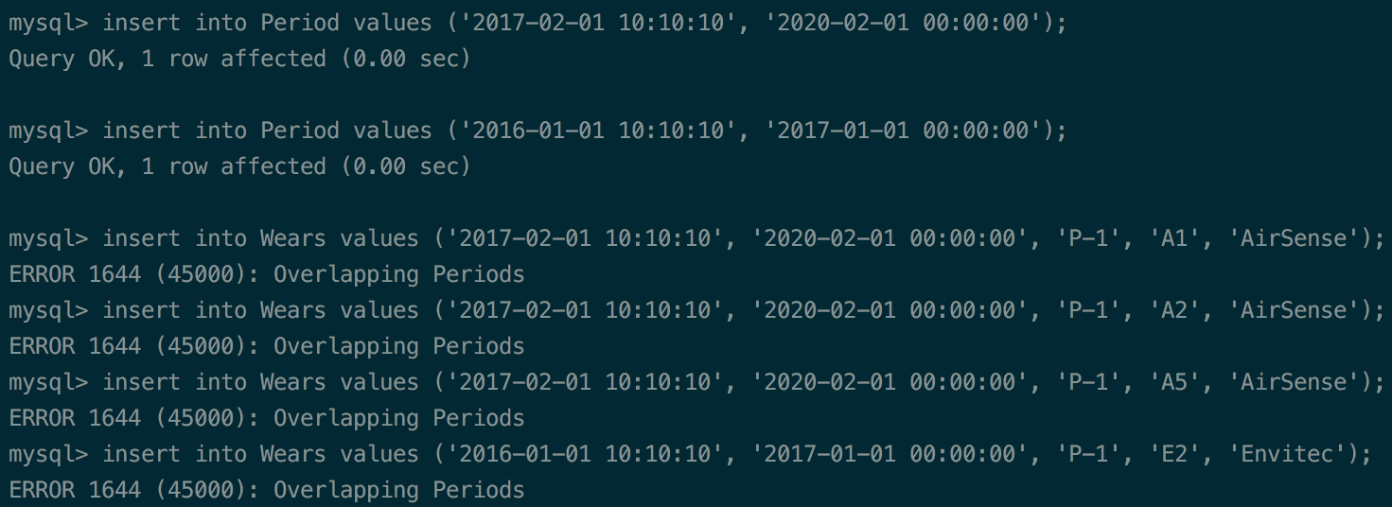

Figure 4.1 - Trigger 2 (prevent_device_association_insert) example for trying to insert records that associates the same device, in overlapping periods, for two different patients, in Wears table

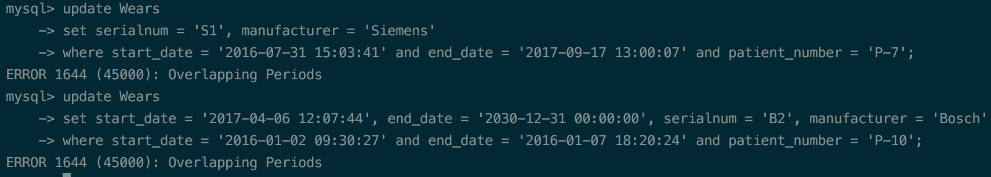

Figure 4.2 - Trigger 2 (prevent_device_association_update) example for updating an existing row, trying to associate a device to different patients, in overlapping periods

* Figure 5.1, 5.2 and 5.3 show examples of the implementation of function *region_overlaps_element()*:

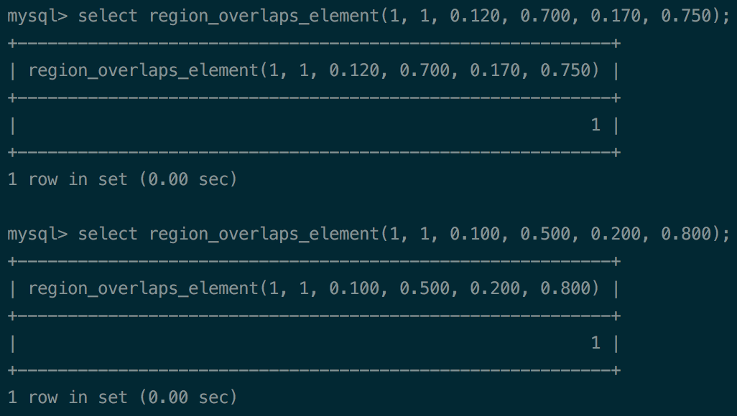

Figure 5.1 - Region B overlaps with region of element A – returns 1, that means TRUE

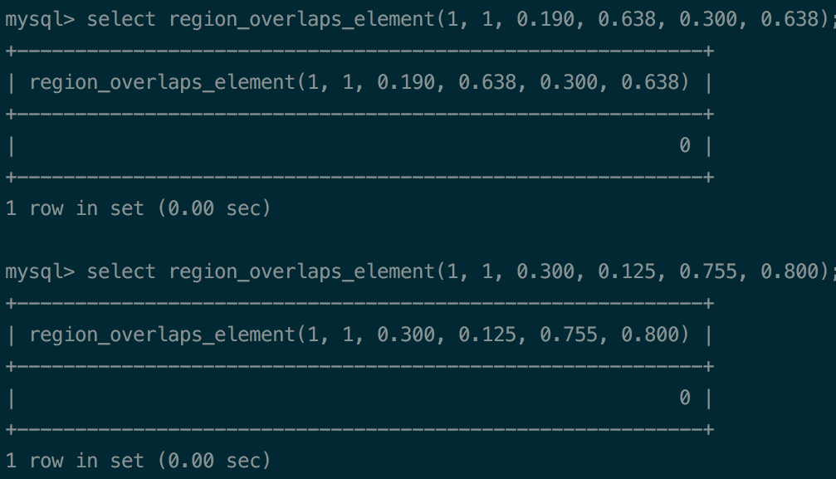

Figure 5.2 – Region B don’t overlap with region of element A – returns 0, that means FALSE

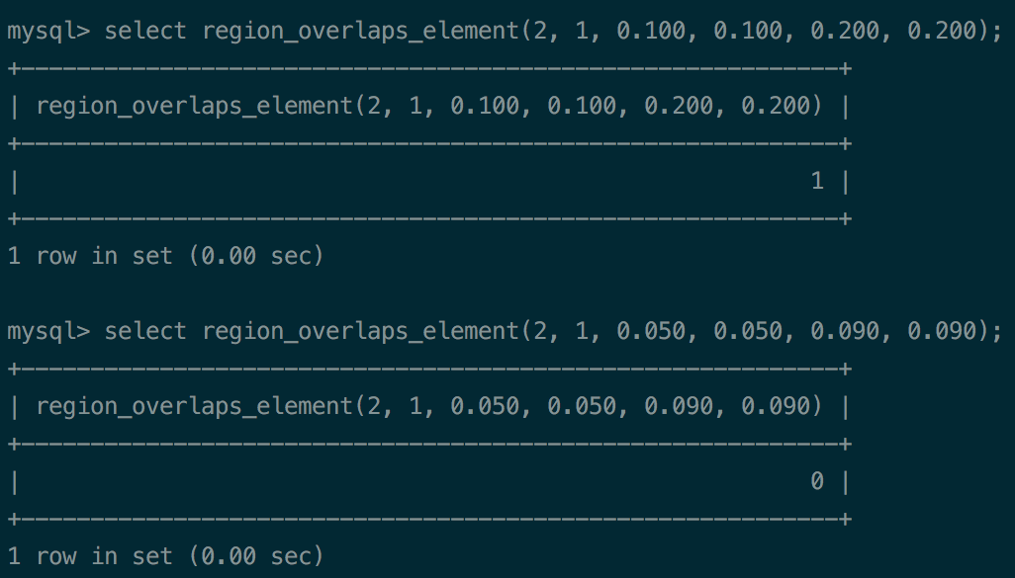

Figure 5.3 – In this case, element 1 from series_id = 2, has two regions and in the first case the given region B overlaps with one of them and in the second case don’t overlap with any of them